Nama : Sammal Jihad

NIM : 18090012

Kelas : 5B

**PRAKTIKUM 1**

1. Source Code

Kenalan.php -> application/controller

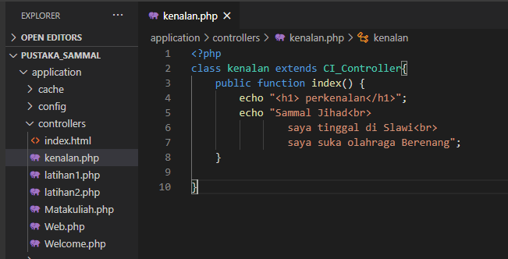

1. URL

<http://localhost/pustaka_sammal/index.php/kenalan>

1. Capture Hasil

